**Output:**

In the output of both normal or naive recursive & optimized recursive can be seen

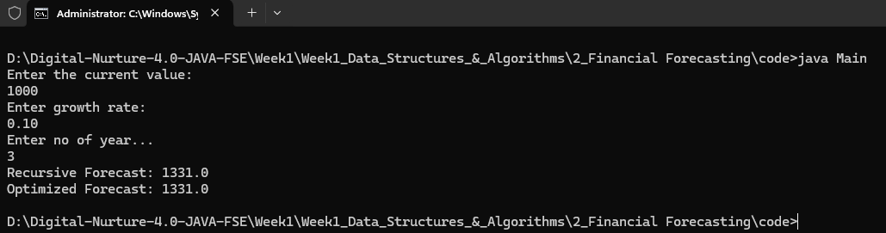

**Analysis:**

The problem uses recursion to simulate compound growth over a number of years by multiplying the current value by *(1 + growth rate)* each year. The basic recursive approach recalculates the same values multiple times, leading to a time complexity of *O(2ⁿ)*. To optimize this, memoization is used to store already computed results for specific years, reducing the time complexity to *O(n)*. This makes the solution much more efficient and suitable for large inputs or repeated queries..